School Of Information Sciences
(A constituent Institute of Manipal University)



TO EXTRACT RADIOMIC FEATURES FROM MAMMOGRAM AND PERFORM CLASSIFICATION USING CONVOLUTION NEURAL NETWORK

Akhil - 171037001
Christon Cardoza - 171037003

Medical Software

Guided By,
Nandish S
ABSTRACT

Breast cancer is one of the leading cancers in the world. The deaths that occur in women increases with increase in the size of tumor shape. Hence, early diagnosis is the key to prevent the deaths from occurring. Various imaging modalities helps in diagnosing the cancer, but these methods should yield correct result to give them a better understanding of the tumor. Various modalities that are used to diagnose breast cancer are x-ray mammography, ultrasound, MRI, thermography etc. The key factor which helps in diagnosis are the processing of images after acquiring the breat region where various image processing techniques come into picture. In our study we have incorporated various methods to effectively detect the tumor, tumor characteristics and various other parameters which helps in classifying the images as malignant or benign. Radiomics helps in analyzing the phenotypes and genotypes of the tumor which helps to distinguish the type of cancer which intern helps in precession medicine for a particular type of tumor. Radiomics extracts advance imaging features such as GLCM, GLZM, GLRM, GLSZM etc. Which can be used for data analytics to classify the tumor as malignant or benign. In our study we use various classifiers such as SVM, logistic regression, KNN, and the most powerful learning algorithm Neural Networks which helps in classification.

Individual Contribution
- First, I did a literature survey on Radiomic feature extraction to get the knowledge about Radiomics and its uses in medical image processing to analyze various types of tumors.
- Secondly, I performed Labeling of 512 number of normal and abnormal masks of mammogram images using 3D slicer.
- After, I Extracted the Radiomic features from the labelled images and its corresponding mammograms.
- Next, I Trained the neural networks and various classifiers in MATLAB by using
Extracted Radiomic features.

CONTENTS
- INTRODUCTION 01
- MATERIALS AND METHODS 02
2.1 BLOCK DIAGRAM 02
2.2. INPUT IMAGE 03
2.2.1. Dataset Description 03
2.3. TUMOR SEGMENTATION 03
2.3.1. Manual Segmentation of Abnormal Regions 04
2.3.2. Manual Segmentation of Normal Region 04
2.4. RADIOMIC FEATURE EXTRACTION 05
2.4.1. First Order Features 06
2.4.2. Shape Features 06
2.4.3. Gray Level Co-occurrence Matrix (GLCM) Features 06
2.4.4. Gray Level Size Zone Matrix (GLSZM) Features 06
2.4.5. Gray Level Run Length Matrix (GLRLM) Features 07
2.4.6. Neigbouring Gray Tone Difference Matrix (NGTDM) Features 07
2.4.7. Gray Level Dependence Matrix (GLDM) Features 07
2.5. NEURAL NETWORK 08
2.5.1. Training an Artificial Neural Network 09
2.5.2. The Iterative Learning Process 09
2.5.3. Feedforward, Back-Propagation 10
2.5.4. Procedure of training a neural network 10

2.6. SUPPORT VECTOR MACHINE 13
2.6.1. Identify the right hyper-plane 13
2.6.2. Pros and Cons associated with SVM 17

3. RESULTS AND FUTURE WORK 19
3.1. RESULT 19
3.2. FUTURE WORK 24

LIST OF FIGURES
FIG:2.1.0: BLOCK DIAGRAM 02
FIG:2.3.1: MANUAL SEGMENTATION OF ABNORMAL REGIONS 04
FIG:2.3.2: MANUAL SEGMENTATION OF NORMAL REGIONS 05
FIG:2.5.1: NEURAL NETWORK 08
FIG:2.5.2: HIDDEN LAYERS OF NEURON 08
FIG:2.6.1: IDENTIFY THE RIGHT HYPER-PLANE SCENARIO-1 13
FIG:2.6.2: IDENTIFY THE RIGHT HYPER-PLANE SCENARIO-2(A) 14
FIG:2.6.3: IDENTIFY THE RIGHT HYPER-PLANE SCENARIO-2(B) 14
FIG:2.6.4: IDENTIFY THE RIGHT HYPER-PLANE SCENARIO-3 14
FIG:2.6.5: IDENTIFY THE RIGHT HYPER-PLANE SCENARIO-4(A) 15
FIG:2.6.6: IDENTIFY THE RIGHT HYPER-PLANE SCENARIO-4(B) 16
FIG:2.6.7: IDENTIFY THE RIGHT HYPER-PLANE SCENARIO-5(A) 16
FIG:2.6.8: IDENTIFY THE RIGHT HYPER-PLANE SCENARIO-5(B) 16
FIG:2.6.9: IDENTIFY THE RIGHT HYPER-PLANE SCENARIO-5(C) 17
FIG:3.1.1: CURVE FITTING INTO THE DATA SET 19
FIG:3.1.2: NEURAL NETWORK RESULT 20
FIG:3.1.3: SUPPORT VECTOR MACHINE (A) 21
FIG: 3.1.4: SUPPORT VECTOR MACHINE (B) 21
FIG:3.1.5: LOGISTIC REGRESSION RESULT(A) 22
FIG:3.1.6: LOGISTIC REGRESSION RESULT(B) 22
FIG:3.1.7: DIFFERENT CLASSIFIERS RESULTS(A) 23
FIG:3.1.8: DIFFERENT CLASSIFIERS RESULTS(B) 23

TO EXTRACT RADIOMIC FEATURES FROM MAMMOGRAM AND PERFORM CLASSIFICATION USING CONVOLUTION NEURAL NETWORK

- INTRODUCTION
Advances in science and technology have led to the understanding that each tumor, even within the same cancer type, has a myriad of distinct genotypic and phenotypic characteristics. A mammogram is an x-ray that allows a qualified specialist to examine the breast tissue for any suspicious areas. The breast is exposed to a small dose of x-ray radiation that produces an image of the breast tissue. Mammograms can often show a breast lump before it can be felt. They also can show tiny clusters of calcium called microcalcifications. Lumps or specks can be caused by cancer, fatty cells, or other conditions like cysts. This heterogeneity among tumors results in a spectrum of responses to treatments, and has led to the evolution of precision medicine. In precision medicine, treatment plans are tailored towards the individual needs of each patient, largely based on their tumor characteristics and predicted therapeutic response, with the promise of improving overall survival and quality of life. The success of precision medicine relies on a means to capture the complexity and intrinsic properties of the tumor that is predictive of the most efficacious treatments. Radiomics is one method that aims to do this non-invasively by creating a quantitative portrayal of the tumor phenotype through the extraction of advanced imaging features from medical images. These radiomic features describe the tumor phenotype through quantifying properties related to its shape, texture and image intensity, and have been predictive of clinical outcomes and tumor characteristics, such as genotype and protein expression

.

2. MATERIALS & METHODS

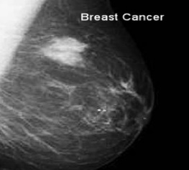
2.1 BLOCK DIAGRAM

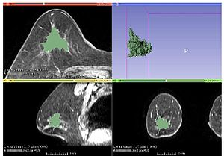
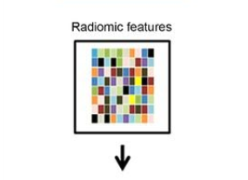
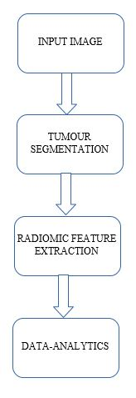

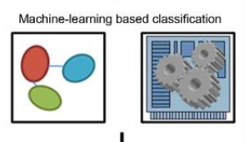

Fig:2.1: Block Diagram

2.2. INPUT IMAGE

Modern CT, MR imaging, and combined PET/CT units allow for wide variations in acquisition and image reconstruction protocols, and standardization of these protocols across medical imaging centers is typically lacking. These are the image types that can be used to extract features from. The image types that are available are determined dynamically. The input image is of the type dicom which is an x-ray image of a breast taken in positions CC (Cranio Caudal) and MLO (Medio Lateral Oblique).

2.2.1. Dataset Description

- The dataset was provided by PHILIPS HEALTH CARE.
- The dataset consisted of 2 types of images.
  - 319 Abnormal mammogram images.
  - Annotated 345 abnormal binary masks of the tumour.
- Dataset are Anonymised dataset.
- The images are of the type DICOM.
- The resolution of the images varied from one image to another.

2.3. TUMOR SEGMENTATION

Segmentation partitions an image into distinct regions containing each pixel with similar attributes. Segmentation divides an image into its constituent regions or objects. It is a difficult task in image processing. Segmentation allows to extract objects in images.

Segmentation algorithms are based on one of two basic properties of color, gray values, or texture: discontinuity and similarity. Discontinuity is to partition an image based on abrupt changes in intensity, such as edges in an image. Similarity are based on partitioning an image into regions that are similar according to a predefined criterion. Histogram thresholding approach falls under this category.

2.3.1. Manual Segmentation of Abnormal Regions

- The segmentation of the tumour is performed using 3D slicer which is an open source tool.
- A mask and a label which is identical to the tumour shape is created using various masking tools available in 3D Slicer.
- The abnormal part in the mammogram image is labelled as shown in figure.

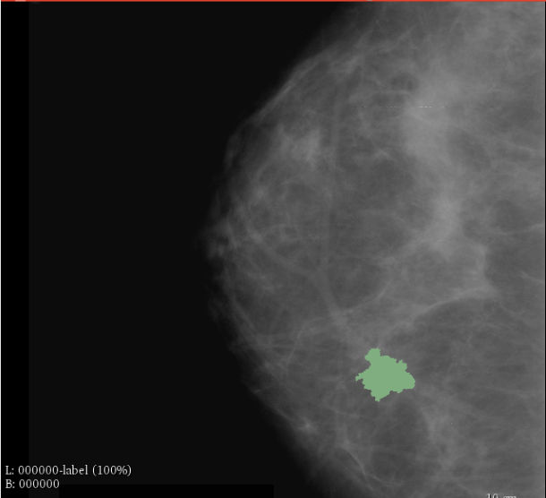

Fig:2.3.1: Manual Segmentation of Abnormal Regions

2.3.2. Manual Segmentation of Normal Region

- Segmentation of the normal regions is performed by creating various rectangular masks.
- Labels are created using the rectangular mask tool in 3D slicer.
- In a mammogram image various such labels are created to acquire the features from the segmented normal labels.

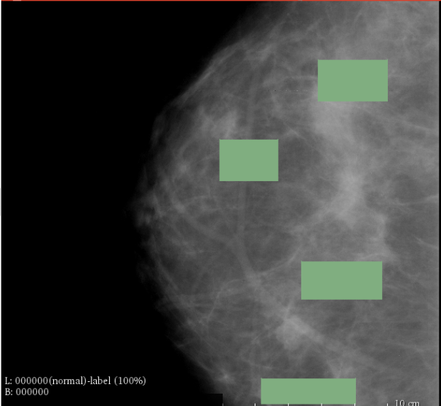

Fig:2.3.2: Manual Segmentation of Normal Regions

2.4. RADIOMIC FEATURE EXTRACTION

Radiomics is a field of medical study that aims to extract large amount of quantitative features from medical images using data-characterisation algorithms. These features, termed radiomic features, have the potential to uncover disease characteristics that fail to be appreciated by the naked eye.

Radiomic features can be divided into five groups: size and shape based–features, descriptors of the image intensity histogram, descriptors of the relationships between image voxels (e.g. gray-level co-occurrence matrix (GLCM), run length matrix (RLM), size zone matrix (SZM), and neighborhood gray tone difference matrix (NGTDM) derived textures, textures extracted from filtered images, and fractal features.

These features are sub-divided into following classes:
- First Order Features (19 features)
- Shape Features (16 features)
- Gray Level Co-occurrence Matrix (GLCM) Features (26 features)
- Gray Level Size Zone Matrix (GLSZM) Features (16 features)
- Gray Level Run Length Matrix (GLRLM) Features (16 features)
- Neigbouring Gray Tone Difference Matrix (NGTDM) Features (5 features)
- Gray Level Dependence Matrix (GLDM) Features (15 features)

2.4.1. First Order Features
First-order statistics describe the distribution of voxel intensities within the image region defined by the mask through commonly used and basic metrics.

2.4.2. Shape Features
In this group of features included descriptors of the three-dimensional size and shape of the ROI. These features are independent from the gray level intensity distribution in the ROI and are therefore only calculated on the non-derived image and mask.

2.4.3. Gray Level Co-occurrence Matrix (GLCM) Features
A Gray Level Co-occurrence Matrix (GLCM) of size 𝑁𝑔 × 𝑁𝑔 describes the second-order joint probability function of an image region constrained by the mask and is defined as P(𝑖, 𝑗|𝛿, 𝛼). The (𝑖, 𝑗) th element of this matrix represents the number of times the combination of levels 𝑖 and 𝑗 occur in two pixels in the image, that are separated by a distance of 𝛿 pixels along angle 𝛼. The distance 𝛿 from the center voxel is defined as the distance according to the infinity norm. For 𝛿 = 1, this results in 2 neighbors for each of 13 angles in 3D (26-connectivity) and for 𝛿 = 2 a 98-connectivity (49 unique angles).

2.4.4. Gray Level Size Zone Matrix (GLSZM) Features
A Gray Level Size Zone (GLSZM) quantifies gray level zones in an image. A gray level zone is defined as a the number of connected voxels that share the same gray level intensity. A voxel is considered connected if the distance is 1 according to the infinity norm (26-connected region in a 3D, 8-connected region in 2D). In a gray level size zone matrix 𝑃(𝑖, 𝑗) the (𝑖, 𝑗) th element equals the number of zones with gray level 𝑖 and size 𝑗 appear in image. Contrary to GLCM and GLRLM, the GLSZM is rotation independent, with only one matrix calculated for all directions in the ROI.

2.4.5. Gray Level Run Length Matrix (GLRLM) Features
A Gray Level Run Length Matrix (GLRLM) quantifies gray level runs, which are defined as the length in number of pixels, of consecutive pixels that have the same gray level value. In a gray level run length matrix P(𝑖, 𝑗|𝜃), the (𝑖, 𝑗) th element describes the number of runs with gray level 𝑖 and length 𝑗 occur in the image (ROI) along angle 𝜃.

2.4.6. Neigbouring Gray Tone Difference Matrix (NGTDM) Features
A Neighbouring Gray Tone Difference Matrix quantifies the difference between a gray value and the average gray value of its neighbours within distance 𝛿. The sum of absolute differences for gray level 𝑖 is stored in the matrix. Let X𝑔𝑙 be a set of segmented voxels and 𝑥𝑔𝑙(𝑗𝑥, 𝑗𝑦, 𝑗𝑧) ∈ X𝑔𝑙 be the gray level of a voxel at postion (𝑗𝑥, 𝑗𝑦, 𝑗𝑧), then the average gray level of the neigbourhood is:
𝐴¯ 𝑖 = 𝐴¯(𝑗𝑥, 𝑗𝑦, 𝑗𝑧)
= 1 𝑊 ∑︁ 𝛿 𝑘𝑥=−𝛿 ∑︁ 𝛿 𝑘𝑦=−𝛿 ∑︁ 𝛿 𝑘𝑧=−𝛿 𝑥𝑔𝑙(𝑗𝑥 + 𝑘𝑥, 𝑗𝑦 + 𝑘𝑦, 𝑗𝑧 + 𝑘𝑧),
where (𝑘𝑥, 𝑘𝑦, 𝑘𝑧) ̸= (0, 0, 0) and 𝑥𝑔𝑙(𝑗𝑥 + 𝑘𝑥, 𝑗𝑦 + 𝑘𝑦, 𝑗𝑧 + 𝑘𝑧) ∈ X𝑔.
Here, 𝑊 is the number of voxels in the neighbourhood that are also in X𝑔𝑙.

2.4.7. Gray Level Dependence Matrix (GLDM) Features
A Gray Level Dependence Matrix (GLDM) quantifies gray level dependencies in an image. A gray level dependency is defined as a the number of connected voxels within distance 𝛿 that are dependent on the center voxel. A neighbouring voxel with gray level 𝑗 is considered dependent on center voxel with gray level 𝑖 if |𝑖 − 𝑗| ≤ 𝛼. In a gray level dependence matrix P(𝑖, 𝑗) the (𝑖, 𝑗) th element describes the number of times a voxel with gray level 𝑖 with 𝑗 dependent voxels in its neighbourhood appears in image.

2.5. NEURAL NETWORK
Artificial neural networks are relatively crude electronic networks of neurons based on the neural structure of the brain. They process records one at a time, and learn by comparing their classification of the record (i.e., largely arbitrary) with the known actual classification of the record. The errors from the initial classification of the first record is fed back into the network, and used to modify the networks algorithm for further iterations.
A neuron in an artificial neural network is
1. A set of input values (xi) and associated weights (wi).
2. A function (g) that sums the weights and maps the results to an output (y).
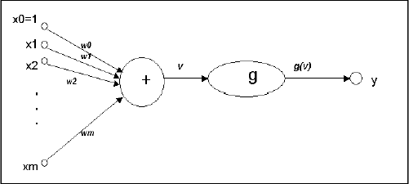
Fig:2.5.1: Neural Network
Neurons are organized into layers: input, hidden and output. The input layer is composed not of full neurons, but rather consists simply of the record's values that are inputs to the next layer of neurons. The next layer is the hidden layer. Several hidden layers can exist in one neural network. The final layer is the output layer, where there is one node for each class. A single sweep forward through the network results in the assignment of a value to each output node, and the record is assigned to the class node with the highest value.
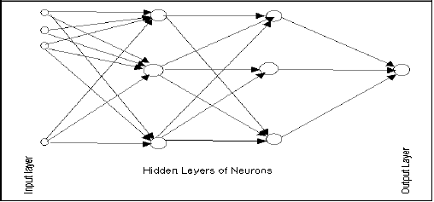
Fig:2.5.2: Hidden Layers of Neuron
2.5.1. Training an Artificial Neural Network
In the training phase, the correct class for each record is known (termed supervised training), and the output nodes can be assigned correct values -- 1 for the node corresponding to the correct class, and 0 for the others. (In practice, better results have been found using values of 0.9 and 0.1, respectively.) It is thus possible to compare the network's calculated values for the output nodes to these correct values, and calculate an error term for each node (the Delta rule). These error terms are then used to adjust the weights in the hidden layers so that, hopefully, during the next iteration the output values will be closer to the correct values.
2.5.2. The Iterative Learning Process
A key feature of neural networks is an iterative learning process in which records (rows) are presented to the network one at a time, and the weights associated with the input values are adjusted each time. After all cases are presented, the process is often repeated. During this learning phase, the network trains by adjusting the weights to predict the correct class label of input samples. Advantages of neural networks include their high tolerance to noisy data, as well as their ability to classify patterns on which they have not been trained. The most popular neural network algorithm is the back-propagation algorithm proposed in the 1980s.
Once a network has been structured for a particular application, that network is ready to be trained. To start this process, the initial weights (described in the next section) are chosen randomly. Then the training (learning) begins.
The network processes the records in the Training Set one at a time, using the weights and functions in the hidden layers, then compares the resulting outputs against the desired outputs. Errors are then propagated back through the system, causing the system to adjust the weights for application to the next record. This process occurs repeatedly as the weights are tweaked. During the training of a network, the same set of data is processed many times as the connection weights are continually refined.
Note that some networks never learn. This could be because the input data does not contain the specific information from which the desired output is derived. Networks also will not converge if there is not enough data to enable complete learning. Ideally, there should be enough data available to create a Validation Set.

2.5.3. Feedforward, Back-Propagation
The feedforward, back-propagation architecture was developed in the early 1970s by several independent sources (Werbor; Parker; Rumelhart, Hinton, and Williams). This independent co-development was the result of a proliferation of articles and talks at various conferences that stimulated the entire industry. Currently, this synergistically developed back-propagation architecture is the most popular model for complex, multi-layered networks. Its greatest strength is in non-linear solutions to ill-defined problems.
The typical back-propagation network has an input layer, an output layer, and at least one hidden layer. There is no theoretical limit on the number of hidden layers but typically, there are just one or two. Some studies have shown that the total number of layers needed to solve problems of any complexity is five (one input layer, three hidden layers and an output layer). Each layer is fully connected to the succeeding layer.
The training process normally uses some variant of the Delta Rule, which starts with the calculated difference between the actual outputs and the desired outputs. Using this error, connection weights are increased in proportion to the error times, which are a scaling factor for global accuracy. This means that the inputs, the output, and the desired output all must be present at the same processing element. The most complex part of this algorithm is determining which input contributed the most to an incorrect output and how must the input be modified to correct the error. (An inactive node would not contribute to the error and would have no need to change its weights.) To solve this problem, training inputs are applied to the input layer of the network, and desired outputs are compared at the output layer. During the learning process, a forward sweep is made through the network, and layer computes the output of each element. The difference between the output of the final layer and the desired output is back propagated to the previous layer(s), usually modified by the derivative of the transfer function. The connection weights are normally adjusted using the Delta Rule. This process proceeds for the previous layer(s) until the input layer is reached.

2.5.4. Procedure of training a neural network
In order to train a neural network, there are four steps to be made:
- Creating a Training Set
- Create a neural network
- Train the network
- Test the network to make sure that it is trained properly
Step 1. Creating a Training Set
Create new training set that is used to teach the network. Named it as radiomic data and set the parameters. There are two types of training used in neural networks, supervised and unsupervised training, of which supervised is the most common. In supervised learning, the network user assembles a set of training data. The training data contains examples of inputs together with the corresponding outputs, and the network learns to infer the relationship between the two. For an unsupervised learning rule, the training set consist of input training patterns only. Supervised learning is done. Then set the number of input, which is 497 because out data, set has 497 input attributes, and the number of outputs is 75. Then load all data directly from file. Values in that file are separated by coma(,).

Step 2 Creating a neural network
Create a new neural network and define name and type of neural network. Neuroph supports common neural network architectures such as Adaline, Perceptron, Multi-Layer Perceptron, etc. This neural network using Multi-Layer Perceptron. This is the most widely studied and used neural network classifier. It is capable of modelling complex functions, it is robust (good at ignoring irrelevant inputs and noise), and can adapt its weights and/or topology in response to environment changes. Another reason will use this type of perceptron is simply because it is very easy to use - it implements black-box point of view, and can be used with few knowledge about the relationship of the function to be modelled.
Problems that require more than one hidden layers are rarely encountered. For many practical problems, there is no reason to use any more than one hidden layer. One layer can approximate any function that contains a continuous mapping from one finite space to another. Deciding the number of hidden neuron layers is only a small part of the problem. We must also determine how many neurons will be in each of these hidden layers. Both the number of hidden layers and the number of neurons in each of these hidden layers must be carefully considered.
The number of input and output parameters in clear. As for the hidden layers, there are two decisions that have to be made. The first is how many hidden layers the neural network should have. Secondly, we must determine how many ons will be in each of these layers. In common use most neural networks will have only one hidden layer. It is very rare for a neural network to have more than two hidden layers. Now we have to determine how many neurons will be in this hidden layer. Using too few neurons will result in underfitting. On the other hand, using too many neurons can result in overfitting. Some compromise must be reached between too many and too few neurons in the hidden layers. There are many rule-of-thumb methods for determining the correct number of neurons to use in the hidden layers. Some of them are summarized as follows.
- The number of hidden neurons should be in the range between the size of the input layer and the size of the output layer.
- The number of hidden neurons should be the input layer size, plus the size of the output layer plus one.
- The number of hidden neurons should be less than twice the input layer size.
For first training attempt, we are going to use the second rule, that is why the number of hidden neurons is 10. We also checked 'Use Bias Neurons' option and chosen 'Sigmoid' for transfer function (because our data set is normalized, values are between 0 and 1). Bias neuron is very important, and the error-back propagation neural network without Bias neuron for hidden layer does not learn. The Bias weights control shapes, orientation and steepness of all types of Sigmoid functions through data mapping space. A bias input always has the value of 1. Without a bias, if all inputs are 0, the only output ever possible will be a zero.

Step 3 Train the neural network
After we had created training set and neural network, we can train neural network. We select training set, click 'Train', and then we have to set up the learning parameters. Before we click train, let us see what the following parameters present.
Learning rate is a procedure, which assesses the relative contribution of each weight to the total error. The selection of Learning Rate is critical importance in finding the true global minimum of the error distance. If it is too small- LR will make really slow progress. In addition, if it is too large it will proceed much faster, but may produce oscillations between relatively poor solution.
Momentum rate can be helpful in speeding the convergence and avoiding local minimum. The idea is to stabilize the weight change by making non-radical revisions using combination of the gradient decreasing term with a fraction of the previous weight change
Step 4 Test the neural network
After training the neural network with the input features and random weights which are initialized in the input layer, there values undergo sigmoid functionality and predict the target. This is called feed forward propagation. The errors are calculated and these errors are back propagated into the 1st hidden layer. The accuracy of the network is calculated by summing the sensitivity and specificity. We gave 75 samples of test input features as input to neurons in the input layer, the weights and errors are checked at each layer and the specific target is reached according to the weights and errors, and the accuracy is achieved accordingly.

2.6. SUPPORT VECTOR MACHINE
“Support Vector Machine” (SVM) is a supervised machine learning algorithm which can be used for both classification and regression challenges. However, it is mostly used in classification problems. In this algorithm, we plot each data item as a point in n-dimensional space (where n is number of features we have) with the value of each feature being the value of a particular coordinate. Then, we perform classification by finding the hyper-plane that differentiate the two classes very well.

2.6.1. Identify the right hyper-plane

Scenario-1

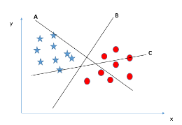
Fig:2.6.1: Identify the right hyper-plane Scenario-1
Here, we have three hyper-planes (A, B and C). Now, identify the right hyper-plane to classify star and circle. We need to remember a thumb rule to identify the right hyper-plane: “Select the hyper-plane which segregates the two classes better”. In this scenario, hyper-plane “B” has excellently performed this job

Scenario-2
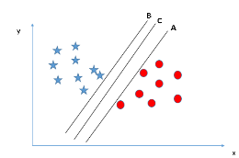
Fig:2.6.2: Identify the right hyper-plane Scenario-2(a)
Here, we have three hyper-planes (A, Band C ) and all are segregating the classes well. Here, maximizing the distances between nearest data point (either class) and hyper-plane will help us to decide the right hyper-plane. This distance is called as Margin.
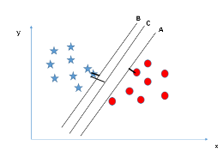
Fig:2.6.3: Identify the right hyper-plane Scenario-2(b)
Above, we can see that the margin for hyper-plane C is high as compared to both A and B. Hence, we name the right hyper-plane as C. Another lightning reason for selecting the hyper-plane with higher margin is robustness. If we select a hyper-plane having low margin then there is high chance of miss-classification.

Scenario-3
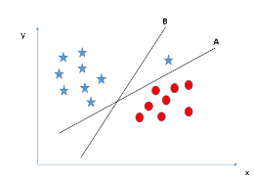
Fig:2.6.4: Identify the right hyper-plane Scenario-3
Here is the catch; SVM selects the hyper-plane which classifies the classes accurately prior to maximizing margin. Here, hyper-plane B has a classification error and A has classified all correctly. Therefore, the right hyper-plane is A.
Scenario-4
In this case, it is unable to segregate the two classes using a straight line, as one of star lies in the territory of other (circle) class as an outlier.
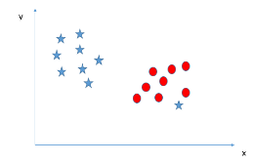
Fig:2.6.5: Identify the right hyper-plane Scenario-4(a)
One star at other end is like an outlier for star class. SVM has a feature to ignore outliers and find the hyper-plane that has maximum margin. Hence, we can say, SVM is robust to outliers.
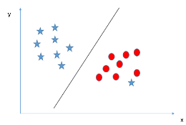
Fig:2.6.6: Identify the right hyper-plane Scenario-4(b)

Scenario-5
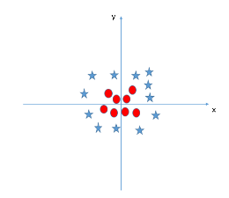
Fig:2.6.7: Identify the right hyper-plane Scenario-5(a)
In the scenario below, we cannot have linear hyper-plane between the two classes. SVM can solve this problem. Easily! It solves this problem by introducing additional feature.
Here, we will add new feature z=x^2+y^2.
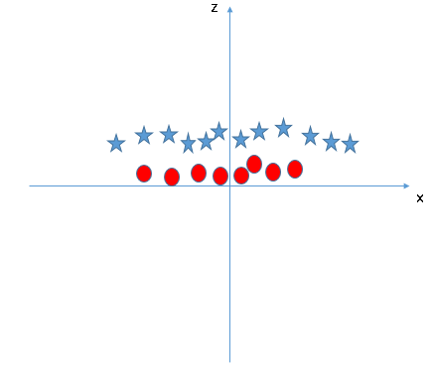
Fig:2.6.8: Identify the right hyper-plane Scenario-5(b)
In above plot, points to consider are:
All values for z would be positive always because z is the squared sum of both x and y. In the original plot, red circles appear close to the origin of x and y axes, leading to lower value of z and star relatively away from the origin result to higher value of z.
In SVM, it is easy to have a linear hyper-plane between these two classes. SVM has a technique called the kernel trick. These are functions which takes low dimensional input space and transform it to a higher dimensional space i.e. it converts not separable problem to separable problem, these functions are called kernels. It is mostly useful in non-linear separation problem. Simply put, it does some extremely complex data transformations, then find out the process to separate the data based on the labels or outputs we have defined.

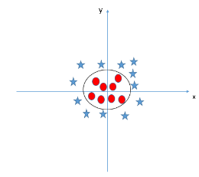
Fig:2.6.9: Identify the right hyper-plane Scenario-5(c)

2.6.2. Pros and Cons associated with SVM
Pros:
- It works really well with clear margin of separation
- It is effective in high dimensional spaces.
- It is effective in cases where number of dimensions is greater than the number of samples.
- It uses a subset of training points in the decision function (called support vectors), so it is also memory efficient.

Cons:
- It doesn’t perform well, when we have large data set because the required training time is higher
- It also doesn’t perform very well, when the data set has more noise i.e. target classes are overlapping

SVM doesn’t directly provide probability estimates, these are calculated using an expensive five-fold cross-validation. It is related SVC method of Python scikit-learn library.

3. RESULTS AND FUTURE WORK

3.1. RESULTS
- Curve Fitting into the data set
  - The figure shows the regression plot of the data set with a specified target.
  - The target is selected by selecting the features from the extracted radimoics.
  - Multiple training is done to fit the model into the dataset.
  - This uses Neural networks during the traning phase.

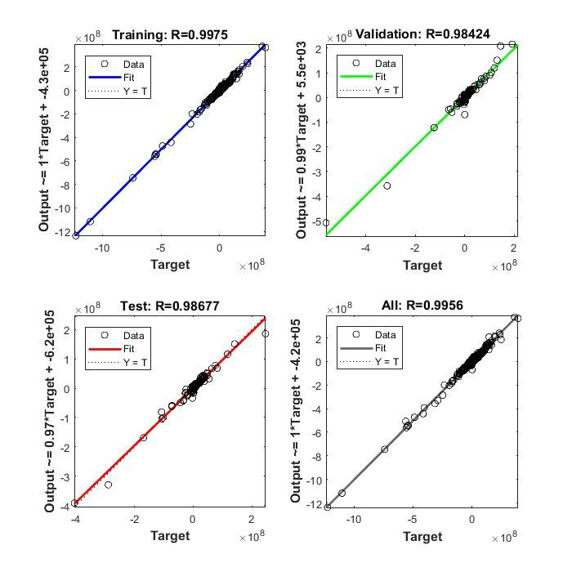

Fig:3.1.1: Curve Fitting Into The Data Set

- Neural Network Result
- Accuracy of 98% was obtained during the testing phase.
- The area under Receiver Operators Characteristics (ROC curve) is a measure of how well a feature can distinguish between two diagnostic groups (normal/abnormal).
- The performance plot shows the performance of the neural network at a certain epoch.

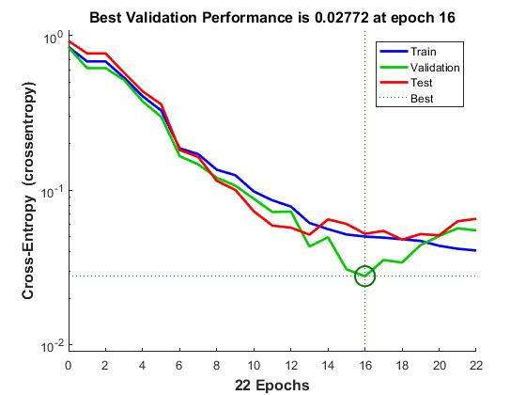
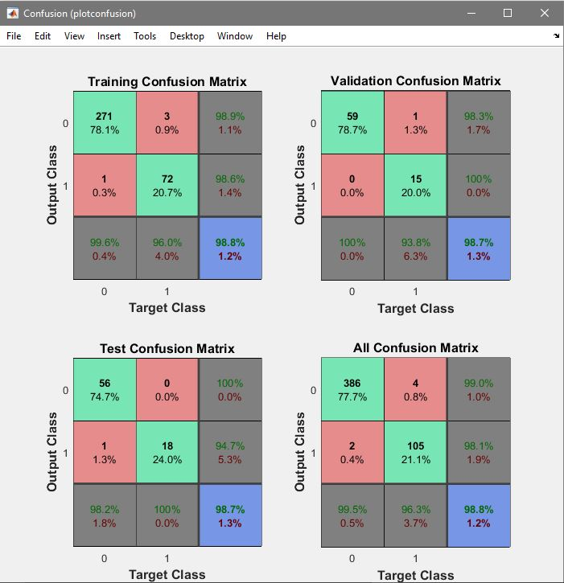
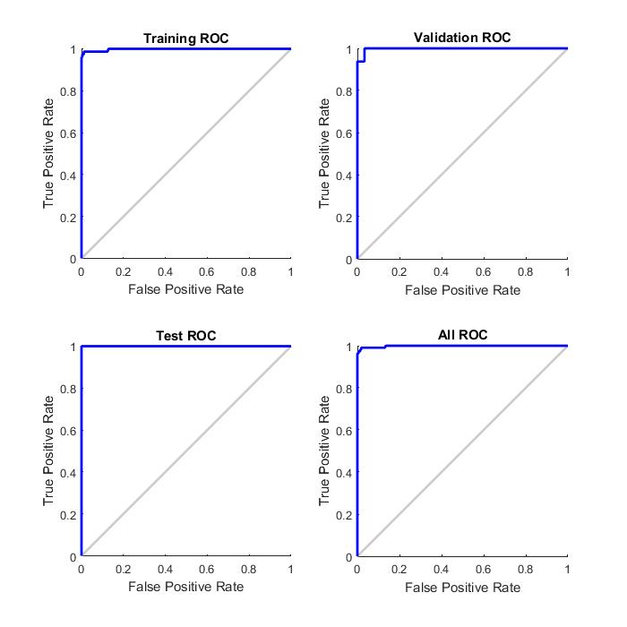

.

Fig:3.1.2: Neural Network Result

- Support Vector Machine
- The linear SVM Classifier was trained with the Radiomic data with the accuracy of 97%.
- The AUC shows how well the classifier has predicted the output during training phase.
- When unknown test data was given to the classifier SVM classified with the accuracy of 99%.
- Totally 364 samples were given for training.
- 27 samples were given for the prediction of output.

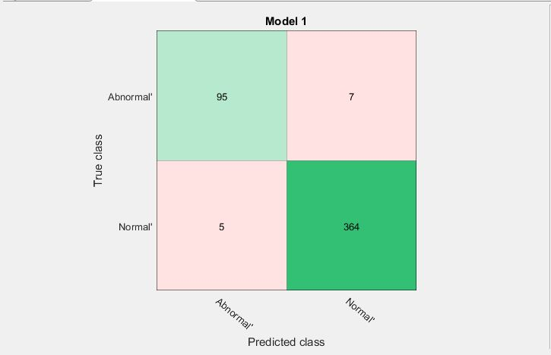
Fig:3.1.3: Support Vector Machine (a)

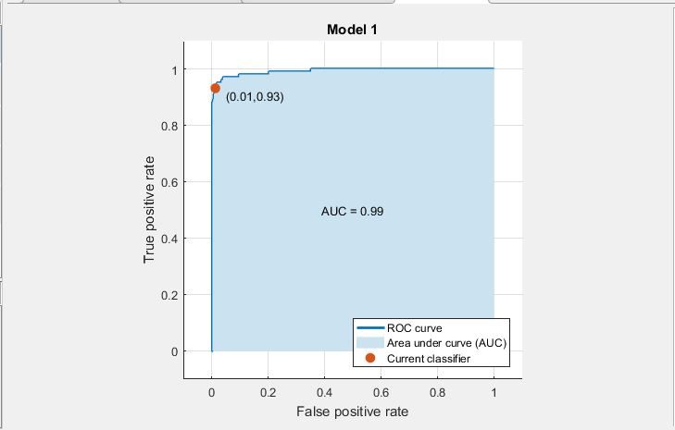

Fig: 3.1.4:Support Vector Machine (b)
- Logistic Regression Result
- Uses SIGMOID function to classify the given data.
- The function makes the prediction of the output to be between 0 to 1.
- A decision boundary (non linear) is drawn to separate 2 classes(Normal and Abnormal).
- An accuracy of 99% was obtained during training and testing phase.

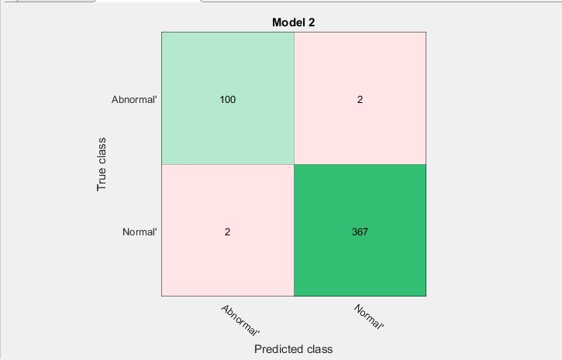

Fig:3.1.5: Logistic Regression Result(a)

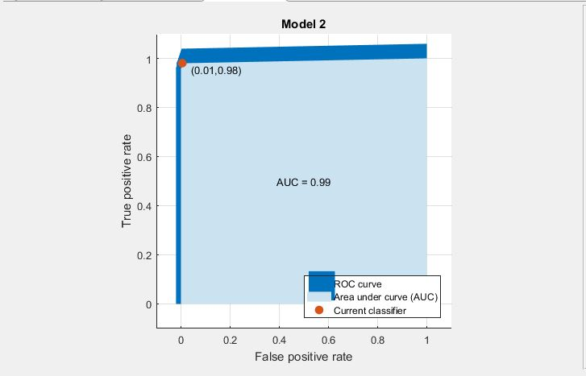

Fig:3.1.6: Logistic Regression Result(b)

- Classifiers Results

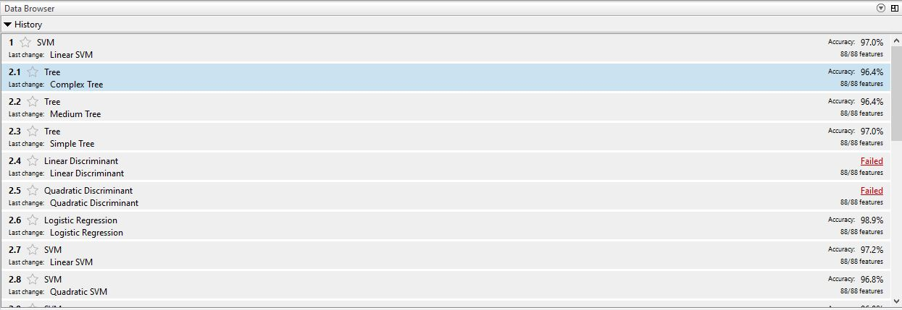

Fig:3.1.7:Different Classifiers Results(a)

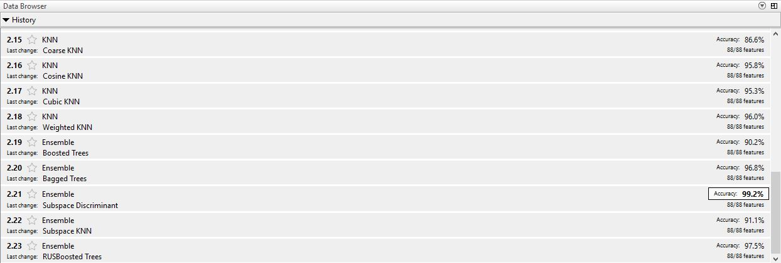

Fig:3.1.8: Different Classifiers Results(b)
3.2. FUTURE WORK
- To develop a Convolution Neural Network classifier using python.
- Train, test and validate the CNN using Radiomic Data.
- To classify the Breast mammograms as Benign or malignant.
- Evaluate the performance of CNN with various other classifiers.

REFERENCES
- Joost JM van Griethuysen, Andriy Fedorov, Chintan Parmar, Ahmed Hosny, Nicole Aucoin, Vivek Narayan, Regina GH Beets-Tan, Jean-Christophe Fillion-Robin, Steve Pieper, Hugo JWL Aerts, “Computational Radiomics System to Decode the Radiographic Phenotype”; Accepted Cancer Research 2017.
- Mathworks.
- Google.

